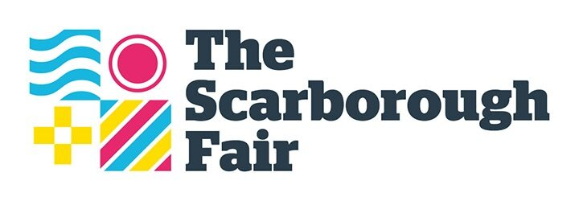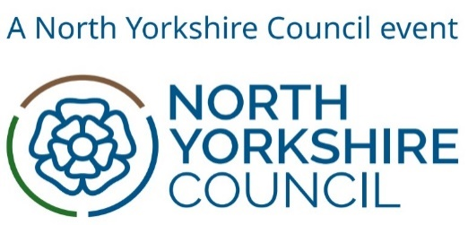

CALL FOR PROPOSALS
Contract title | Scarborough Lights 2024
Type of supply | Light installations and/or light art to be part of the Scarborough Lights Festival (Nov/Dec 2024)

CLOSING DATE: 9am, Monday 1st July 2024

SECTION 1: INTRODUCTION AND GUIDANCE

General
“The Scarborough Fair” is a North Yorkshire Council project, with additional funding from the Towns Deal, or anyone acting on behalf of The Scarborough Fair, that is seeking to invite suitable suppliers to participate in this call for proposals.

“You”/ “Your” or “Supplier” means the body responding to this Call for Proposals i.e., the legal entity responsible for the information provided. The ‘Supplier’ is intended to cover any economic operator as defined by the Public Contracts Regulations 2015 as amended and could be a registered company; charitable organisation; Voluntary Community and Social Enterprise (VCSE); Special Purpose Vehicle; Individual, or other form of entity.

Scope of requirements
The Scarborough Fair wishes to award a contract to produce light installation to support Tourism and Cultural promotion for Scarborough and garner a sense of place to make residents proud of the area in which they live. Scarborough Lights takes place across the town centre from November-December 2024, but we expect there to also be some community workshops and activities for residents in the weeks leading up to the event itself.

This is the second ‘Scarborough Lights’ project in the overall The Scarborough Fair festival, as The Scarborough Fair looks forward to supporting economic growth in the visitor economy sector and create a body of cultural significance across Scarborough. We expect the delivery of Scarborough Lights to have some elements from 2023, but also some very different ideas and installations, in other areas of the town.
Further information is contained within Section 2: The Specification.
Timetable
The draft timetable below outlines the estimated duration of the procurement process. Suppliers should note this is for indicative purposes only and The Scarborough Fair is not bound by these timescales.

Date | Activity
Monday 3rd June 2024 | Calls for Proposals made available to suppliers
9am, Monday 1st July 2024 | Final date for Proposal submissions
w/c Monday 8th July 2024 | Contract awards and commencement of contract

SECTION 2: SPECIFICATION
Introduction
The Scarborough Fair is seeking to commission light art installations for Scarborough Lights, to promote the cultural product of Scarborough and brighten up the town in the winter months, pre-Christmas. This is part of a wider work plan to come together to promote tourism and local enjoyment for Scarborough during The Scarborough Fair, which has already seen Scarborough Streets, Scarborough Art and Scarborough Fringe in 2024.

Background
Scarborough Lights is the next event under the banner of the new Scarborough Fair, taking place between November to December 2024 at various locations in the centre of Scarborough.
It will be an inclusive light festival, taking place in the pre-Christmas period, but not necessarily Christmas-themed, featuring a variety of free and affordable light shows, light installations and community activities. The aim is to inspire, celebrate and showcase local creativity. It will also feature national and international artists, too.
We are looking for a variety of artists, creatives and community groups to be part of the festival, creating new or existing work and developing networks and activities within the town.

Project Brief
The theme and content of installations are up to the Supplier to propose and can be subject to further discussion with The Scarborough Fair once the Proposal has been submitted. We also welcome interactive digital/AR work. All installations are intended for public view during November and December 2024.
Project Area | Budget range (per installation, including materials)
INDOOR Light Installations  We are looking for proposals for both large and small light installations, which we intend to place within churches and other buildings across Scarborough. In your proposal, you can also state locations for which you think it could be suitable. Light artworks can be physical constructions or projected work. If projected, the cost must also include that of the projector. If projection is used, it should take into account the unique nature of the architecture of the location used, and not simply onto a screen. | £1,000-£5,000
OUTDOOR Light Installations  We would like to install a series of outdoor light installations at height on Eastborough or Newborough (eg on cables across the street, on lampposts, on or in buildings, attached to railings). It is important that these are suitable for all weather conditions and are completely out of reach of the general public. We will cover the costs of installing, maintaining and removing artworks. | £1,000-£5,000 per installation
Projection Mapping  We are seeking light art professionals to create projection mapping installations for the Rotunda Museum, Scarborough Gallery, Woodend Gallery and Scarborough Market Hall. At this stage, we are looking for experienced light artists who are able to create the works. If we are considering your proposal, we will invite you for a site visit to work it out further with our partners. You need to consider how and where the projector(s) will be installed, bearing in mind the weather conditions and the need for them to be kept out of reach of the general public from a security perspective. Ideally these works will be visible for the duration of Scarborough Lights, but in some cases we may have to run them for a shorter period of time. | £5,000-£10,000 per building
“OPEN” Category  This is an opportunity for you to propose works that do not necessarily fit into any of the above categories. We are keen to hear ideas and will look to see where they may be able to fit into the programme. Please note that the location of any artwork, display or installation must be within Scarborough. | £1,000-£5,000
Notes regarding Project Brief submissions:
- Open to local, national and international artists
- The Proposal from the Supplier should also include a proposed fee for the work (excluding VAT) and a detailed breakdown
- Links to and involvement with local community groups, charities, schools and colleges are encouraged
- The Scarborough Fair will provide logistics and other permissions for the installations, as part of the overall festival, subject to discussion with the Supplier
- Any assets created within this commission will be solely owned by The Scarborough Fair, for their sole use to promote Scarborough, unless otherwise agreed in writing.

Outputs
- Attracting increased visitor numbers to Scarborough Town Centre
- Improved perception of Scarborough and its cultural offering
- An all-inclusive access installation which can be enjoyed by everyone.

Next Steps
Please provide a Proposal for your project including:
- Theme and detail of the activity proposed
- Timeline of all activities and key dates (including set-up and de-rig, where required)
- Equipment and personnel required
- Previous experience in delivering events of this kind, including specific examples and outcomes
- Full breakdown of costs.
In your Proposal, please state clearly which project brief you are applying to.
Please email your proposal to info@scarboroughfair.uk by 9am, Monday 1st July 2024.

Client Contacts
Day-to-day project contact: Julian Caddy and Catherine Goble (The Scarborough Fair).

