How to register your Scarborough Extreme Event in Eventotron
Go to www.eventotron.com and click the pink login/sign up button
Enter your details into the ‘New Users’ box and click Register | 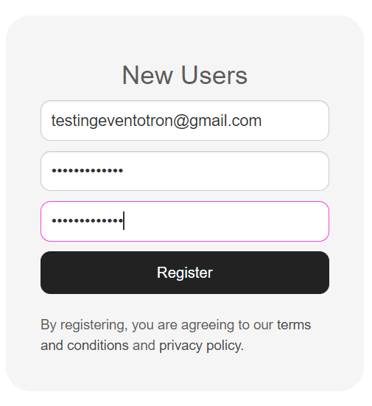
Click on Festivals and Seasons in the top bar
Click the drop down to United Kingdom

Scroll down to Scarborough Extreme and click Apply | 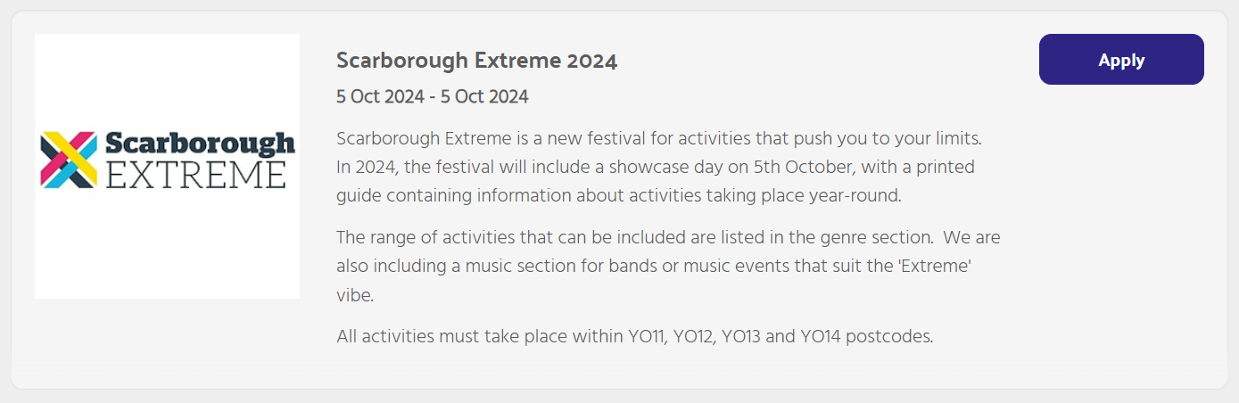
Enter the name of your event/business/group and click next and then Continue. | 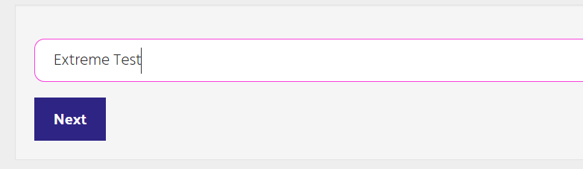
Now fill in all the information you can in the sections ‘About my Company’ and ‘About my Event/Activity’ | 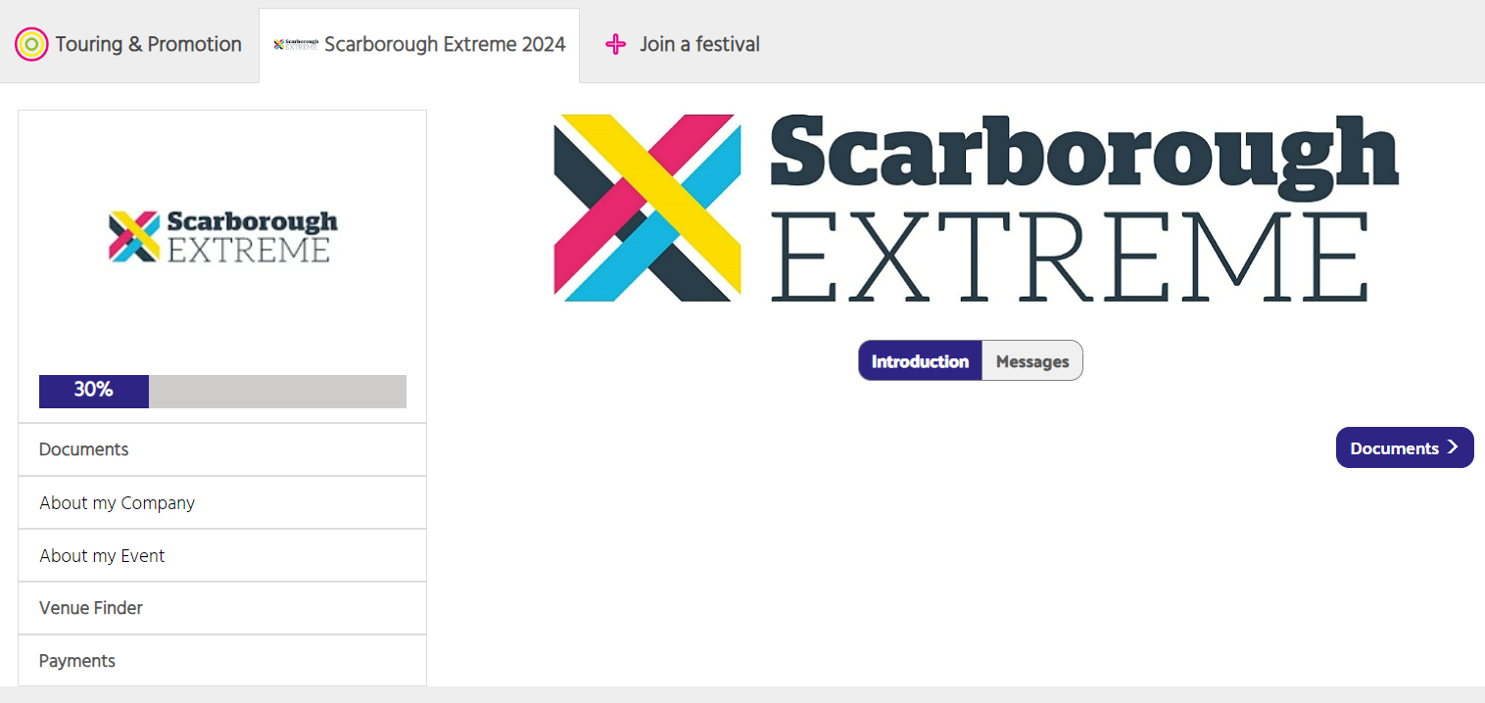
IMPORTANT NOTES: | - Make sure you fill in as much information as possible  - Ensure that ALL of the boxes in red are filled in or you will not be able to finalise your registration  - If your activities cross different genres, you may need to create additional entries for each genre.  - You will need to create a separate entry if you are planning to do a specific activity or event on the 5th October Showcase Day
Venue Finder (ignore) | It is not necessary to complete this section.
Click to finalise your registration.  When you have completed all the necessary sections, you can click the button to finalise once it reaches 100% and turns orange. | 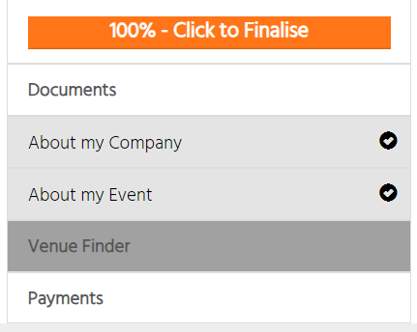
Review the terms and conditions and your entry information.  If you would like to change anything, you can go back to do so at this point. | 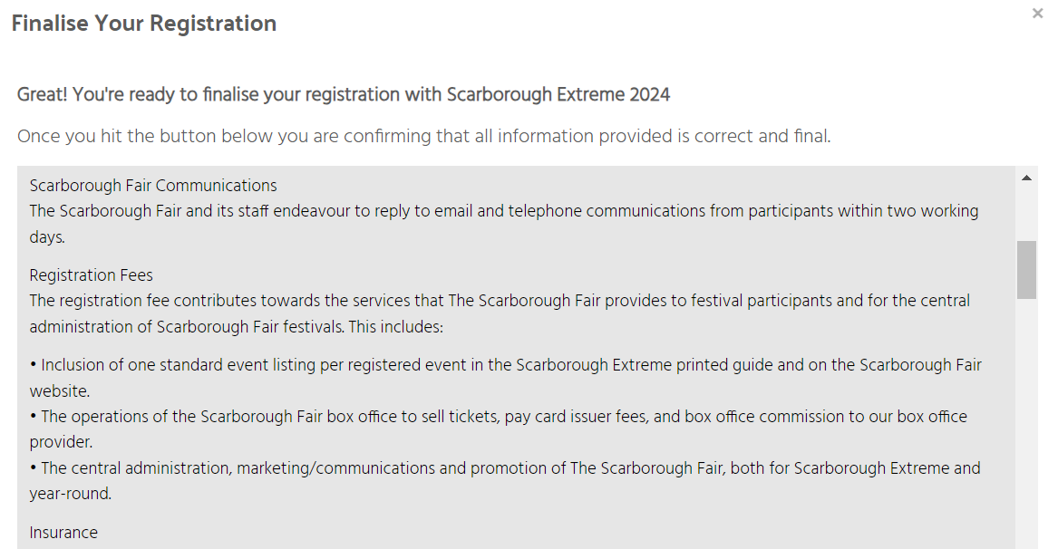
Submit Payment of £20 to finalise your registration (enhanced listing only). | 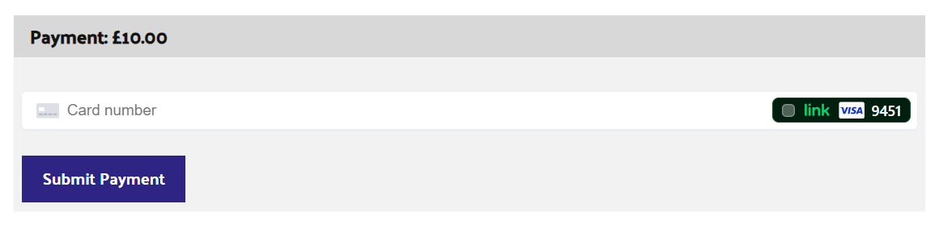

You have now completed your registration!
If there are any questions or if you need to make any changes to the information that you have entered, please email us at info@scarboroughfair.uk.

